**November 5th 2020**

Github repository has been created.

Initial idea has been thought of – Side scrolling dungeon runner game with combat and making use of a virtual gamepad.

**November 12th 2020**

Sprites have been created for the player, enemy and flooring.

Basic level design has been created.

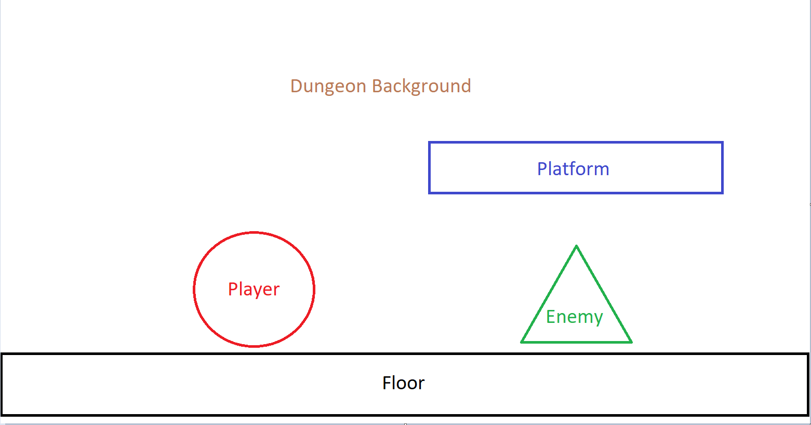

**November 14th 2020**

Floor has been implemented and a circle has been drawn for player until sprite implementation.

**November 15th 2020**

Joystick implementation has been started.

**November 20th 2020**

Joystick has changed from 360-degree joystick to slider joystick

Jump button has been drawn into the game also.

Flow Diagram Created.

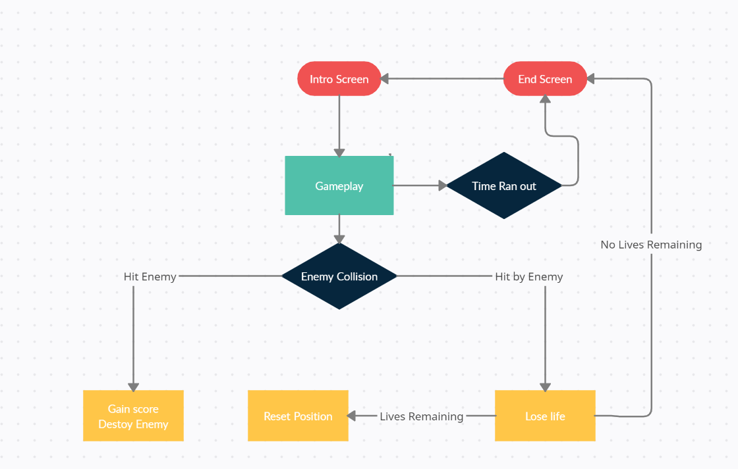

**November 27thth 2020**

Jumping and movement is working.

A rectangle has been drawn in for the enemy until sprite implementation.

**December 2nd 2020**

Collision has been implemented between player and enemy.

Sprite background has been created but not yet implemented.

**December 3rd 2020**

Code has been cleaned up and separate scripts have been created for more readability.

**December 6th 2020**

Background has been implemented.

**December10th 2020**

Slider and jump UI buttons have been created.

**December11th 2020**

Slider and jump UI buttons have been implemented.

**December20th 2020**

Pause and play UI have been created and implemented. Functionality still to be added.

**December29th 2020**

Pause and play functionality has been implemented. Text on screen notifying the player of lives and score have been added.

**January 2nd 2021**

Intro screen and end game screen have been created and implemented.

**January 3rd 2021**

Timer function has been added and brings player to end screen when time runs out.

**January 6th 2021**

Game now works on browser as well as mobile.

**January 8th 2021**

Sound has been added when the player is hit, the player dies, and the enemy is destroyed.

**January 9th 2021**

Music has been implemented and the documentation has been started.

**January 11th 2021**

The PowerPoint for the presentation has started and will be recorded on the 14th.

**January 13th 2021**

Documentation and PowerPoint has been finished and will be recorded still on the 14th.

**January 14th 2021**

Presentation has been recorded. The file is in the Github located at:

<https://github.com/CMCSHE201/Mobile-Game-Development-CMCSHE201>